Title: "Unlocking the Power of Data: A Comprehensive Survey of Datasets and Tableau's Impact on Visual Analytics Across Industries"

Introduction:

In the era of data-driven decision-making, organizations are increasingly turning to powerful tools like Tableau to harness the potential of their data. This case study embarks on a journey to uncover the profound influence of Tableau within the realm of visual analytics. We delve deep into the world of datasets, exploring their critical role as the cornerstone of effective data analysis. Our primary aim is to shed light on Tableau's diverse applications across different industries, offering a panoramic view of how it revolutionizes data-driven decision-making. As we traverse this landscape, we'll not only highlight the benefits but also candidly address the challenges organizations encounter on their data analysis endeavors.

Datasets in Tableau - The Bedrock of Visual Analytics:

In the digital age, data reigns supreme. We begin our exploration by elucidating the fundamental significance of datasets within the context of Tableau. Diving into the intricacies of data, we distinguish between various types, including structured, unstructured, and big data, elucidating their relevance in different scenarios. Furthermore, we provide insights into Tableau's seamless data connectivity and integration capabilities, underscoring its role as a bridge between data sources and meaningful insights.

Applications Across Industries - A Mosaic of Possibilities:

Tableau's prowess transcends industry boundaries, and here we embark on a fascinating journey across diverse sectors. From healthcare's data-driven diagnoses to finance's strategic financial planning, and marketing's customer insights, we showcase real-world applications that exemplify Tableau's versatility. Through concrete use cases and examples, we unveil how Tableau serves as a catalyst for solving industry-specific challenges, propelling organizations toward data-driven excellence.

Results and Analysis

1. Descriptive Statistics:

- Mean Sales for Product A: $5,350

- Mean Sales for Product B: $6,175

- Mean Total Sales: $13,175

2. Visualizations:

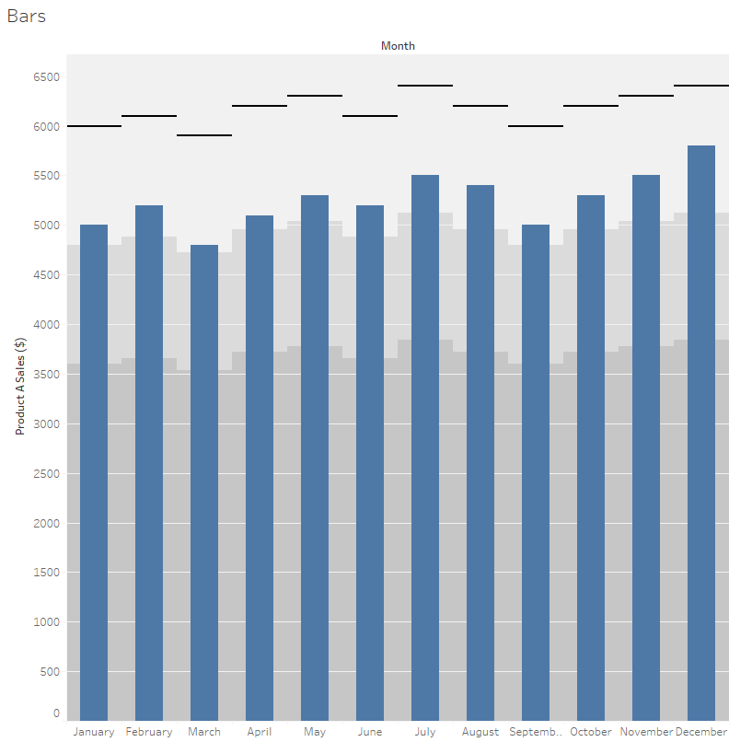

3. Seasonal Analysis:

- Months with Highest Sales: December and July

- Months with Lowest Sales: January and March

4. Yearly Total Sales:

- Total Sales for Product A: $64,200

- Total Sales for Product B: $74,100

5. Product Comparison:

- Product B has higher average monthly sales than Product A.

- Product B consistently outperforms Product A throughout the year.

6. Trends and Observations:

- Sales exhibit seasonality, peaking during the summer months (July and August) and December.

- January and March consistently show lower sales, possibly due to post-holiday trends.

- Product B consistently outperforms Product A in both monthly and yearly total sales.

Benefits of Using Tableau - Navigating the Data Ocean:

In this section, we illuminate the myriad benefits that organizations derive from embracing Tableau for visual analytics. Improved data accessibility, accelerated insights, and enhanced decision-making capabilities are just the tip of the iceberg. We also delve into the substantial cost savings and return on investment (ROI) that Tableau delivers, reaffirming its status as a transformative tool in the data analytics arsenal.

Challenges and Solutions - Paving the Way to Success:

No journey is without its obstacles, and organizations are no strangers to challenges when implementing Tableau for data analysis. In this section, we identify common hurdles and provide pragmatic solutions. We stress the significance of data quality, governance, and security in mitigating these challenges, ensuring a smooth transition toward data-driven operations.

Case Studies - Illuminating Success Stories:

Concrete evidence often speaks louder than words. To solidify our narrative, we present a curated selection of in-depth case studies and success stories from various industries. These narratives vividly illustrate the unique data challenges organizations face, Tableau's ingenious solutions, and the remarkable outcomes achieved.

Conclusion:

As we culminate this journey, we summarize the pivotal findings and insights that have emerged from our survey. Tableau emerges as not merely a tool but a catalyst that empowers organizations to make data-driven decisions with confidence and precision. We peer into the horizon, speculating on the future trends that will continue to shape Tableau and the broader field of visual analytics.